**Final Project**

**Store Front**

**CSC-17B**

**40502**

**6/12/2020**

**Martin Perina**

**Table of Contents**

1. Intro

2. How to Use with Sample Input and Output

3. Development Summary

4. Checklist

5. References

6. Screenshots

7. Pseudo Code

8. Code

**1 Intro**

For my project I decided to make an e-commerce website that sells CPU’s. The website consists of a login page and a main store page. The login page allows a user to create an account if they do not already have one as well as login. Upon logging in, the user will be sent to the main store page where they can select the CPU’s they want to buy. I integrated a cart, checkout, and logout mechanism into the main store page. The website is very simple and has room for expansion.

GitHub Location: In 17B/Store_Front_Final/ Folder

<https://github.com/mperina11/My_Work>

**2 How to Use with Sample Input and Output**

This project can be launched from the NetBeans IDE (I used version 8.2) using the ‘loginpage.html’ file. The website will open in a browser window and the user will be greeted with a login page. You may use the existing user credentials (User: Adam, Password: West) or create a new account. Using these credentials, the user may now login, once done the user will be sent to the main store page. In the main store page the user has four options, to logout, which is in the top left, to select a product, click on the desired product, to view the contents of the cart, which is in the top right, to checkout, which is button option in the cart.

**3 Development Summary**

The development of this project was very slow and spanned over many weeks. Being new to web development, I was forced to research and practice various parts. I started by making small websites that had one simple functionality, for example a button that opens a form, simple formatting of titles and images, and reading writing from a database. Once I had made each part work individually, I then combined everything into one website.

The biggest challenge for me was figuring out what method to use to make different languages/files communicate effectively. I experimented with JavaScript and PHP and ultimately sided more with using PHP out of preference.

Ultimately, I learned a lot about web development, more than I thought I would. I now know how to format and style a webpage, create buttons and forms, communicate with a database, and some simple security. I do have a lot to improve on however, my website could have more functionality and features as well as more security.

**4 Checklist**

1. MVC - How you delineated your objects

-made a list

2) Objects - Javascript/PHP - Serialization

Passing info with Javascript Objects to PHP Objects with Cookies

-NA

3) Reading/Writing Files/Local Storage

JSON – Javascript

-products.json

-used to store products

4) Databases SQL - Identify Entities, Xref, and Enum Tables

-cart, checkout, login, session, user

-enum_product

-xref_cart_product, xref_user_cart

5) Form Validation - Reqular Expressions

-createaccount.php

-used to clean user input

6) User-Admin-Login

-login.php, logout.php

-Login for users

7) Cookies - Sessions - Securing Pages

- login.php and logout.php

- sets unique ID for user

**5 References**

https://www.w3schools.com/

**6 Screenshots**

Figure A: Login Page

Figure B: Login form

Figure C: Create Account Form

Figure D: Store Page

Figure E: Cart

Figure F: Checkout

Figure G: DB Table

A

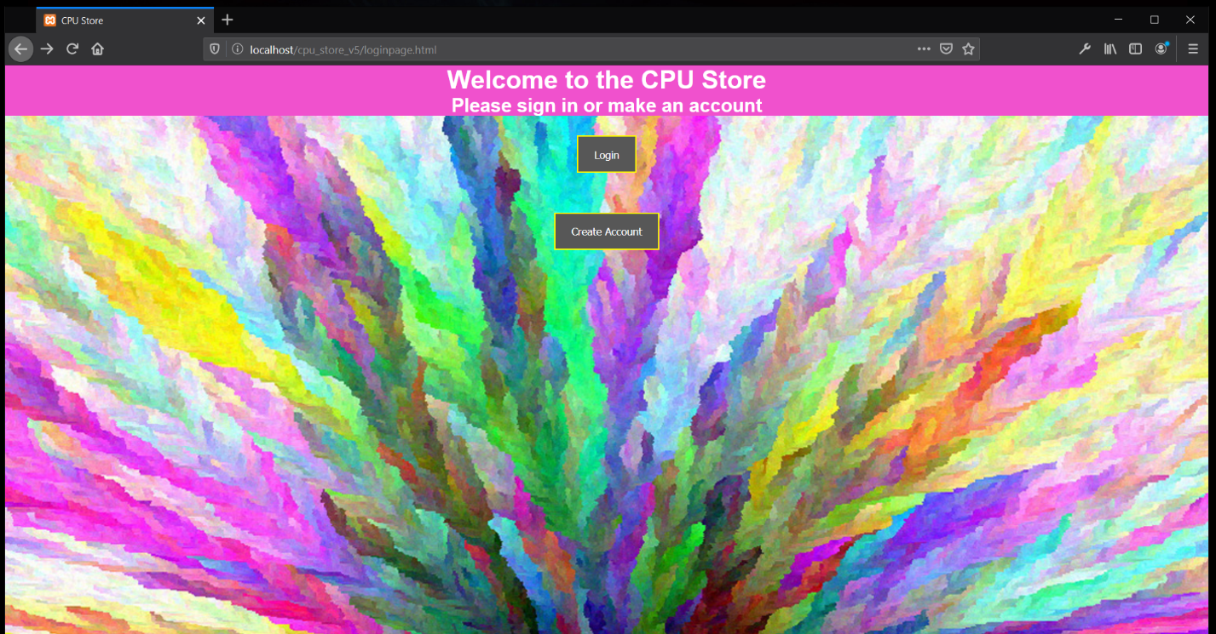

B

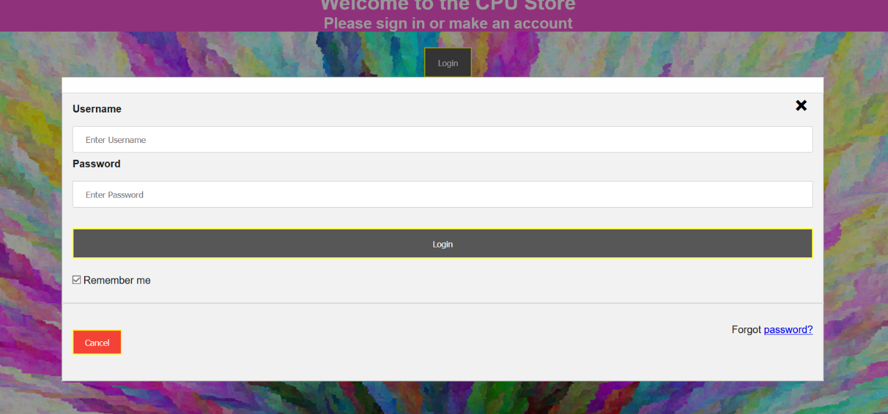

C

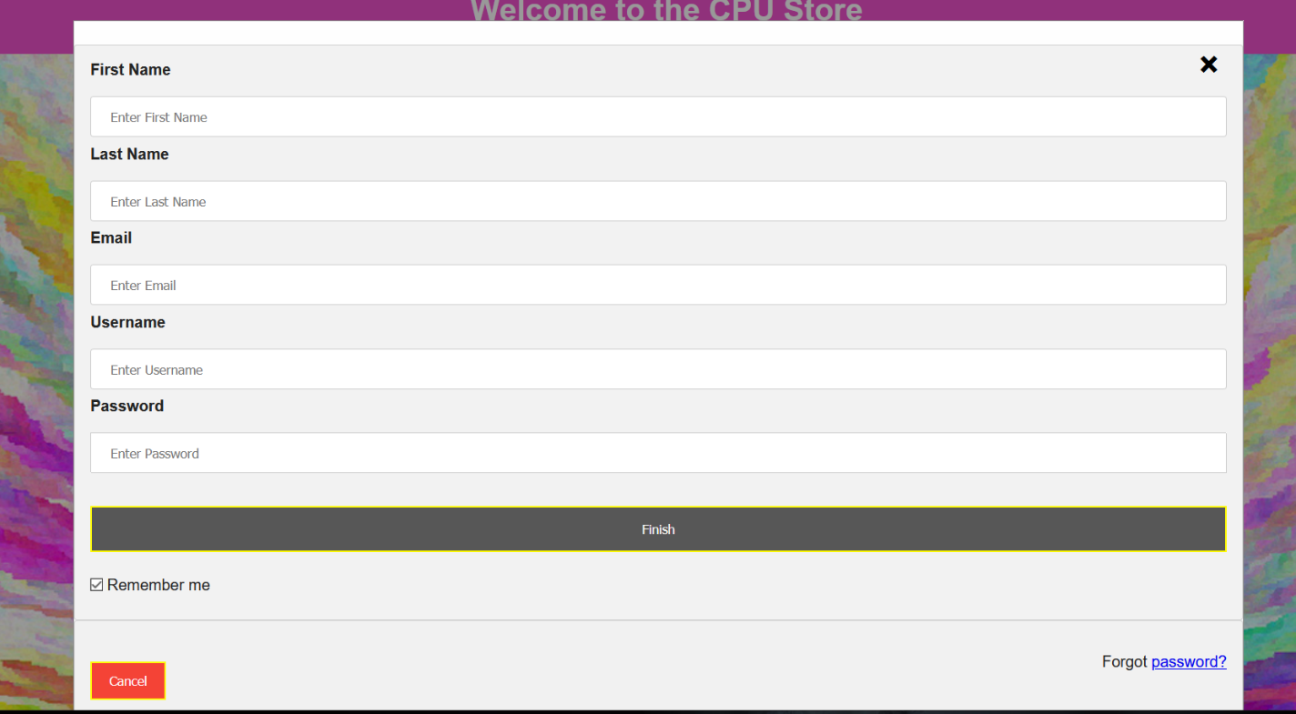

**D**

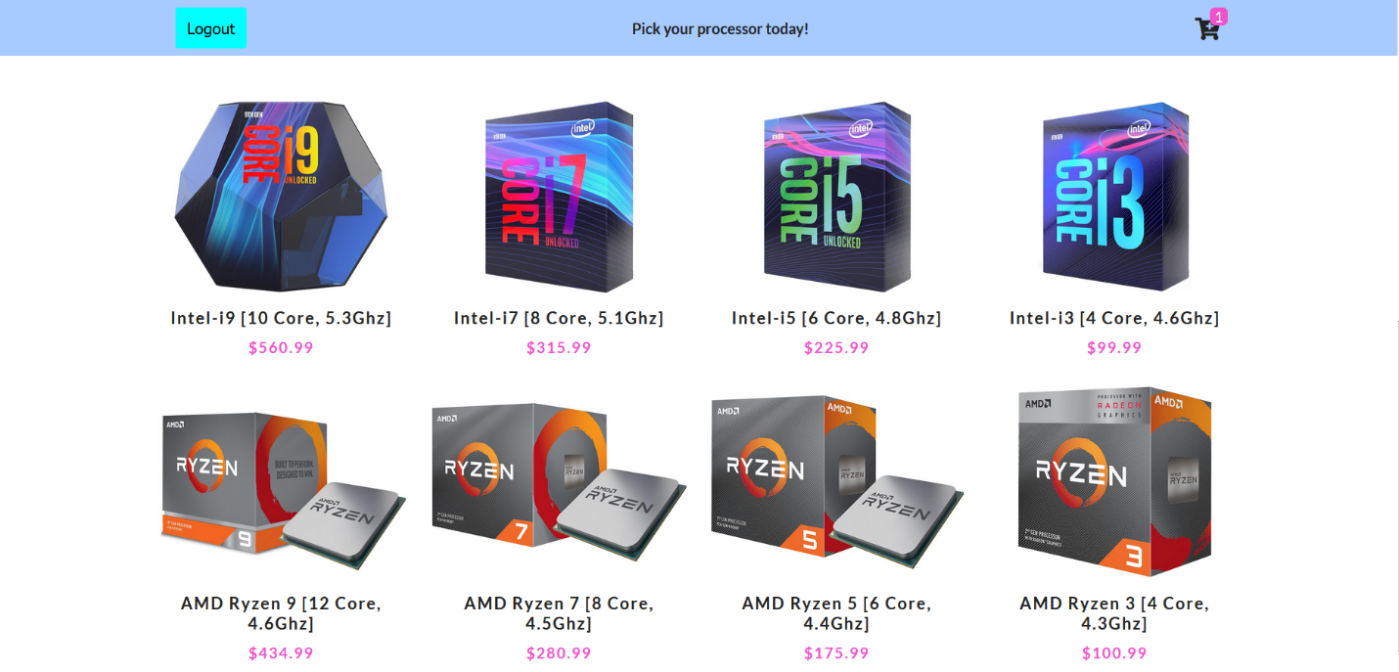

**E**

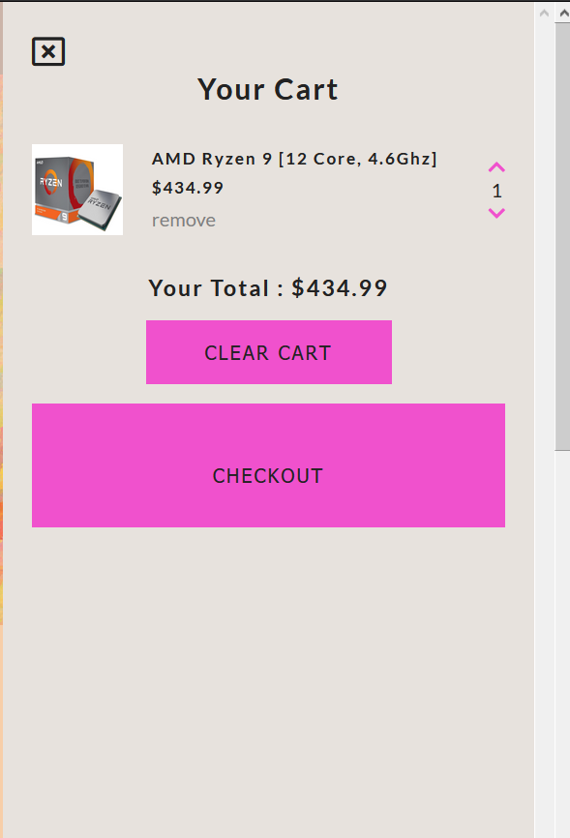

**F**

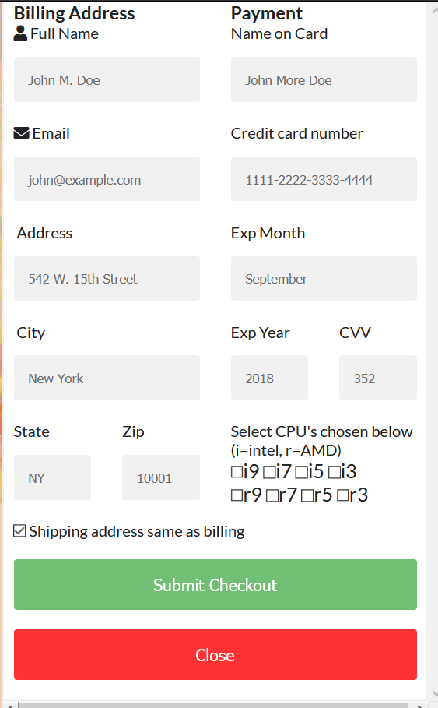

**G**

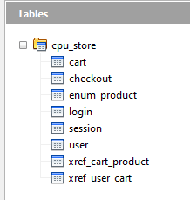

**7 Pseudo Code**

loginpage

if login

enter username and password

check against database

log the time in database

send to main page

if create account

enter username, password, first name, last name, email

check with REGEX

mainpage

if logout

send user back to loginpage

log tim in database

if click product

add product to cart

if cart

show overlay of cart with items

if checkout

show checkout form

store data in database

**8 Code**

<!DOCTYPE html>

<html lang="en">

<head>

<meta charset="UTF-8" />

<meta name="viewport" content="width=device-width, initial-scale=1.0" />

<meta http-equiv="X-UA-Compatible" content="ie=edge" />

<title>CPU Store</title>

<link

rel="stylesheet"

href="https://use.fontawesome.com/releases/v5.8.1/css/all.css"

integrity="sha384-50oBUHEmvpQ+1lW4y57PTFmhCaXp0ML5d60M1M7uH2+nqUivzIebhndOJK28anvf"

crossorigin="anonymous"

/>

<link rel="stylesheet" href="main.css" />

<!--log in form-->

<head>

<meta name="viewport" content="width=device-width, initial-scale=1">

<style>

body {

font-family: Arial, Helvetica, sans-serif;

background: url("./images/backround1.jpg") center no-repeat;

}

/* Full-width input fields */

input[type=text], input[type=password] {

width: 100%;

padding: 12px 20px;

margin: 8px 0;

display: inline-block;

border: 1px solid #ccc;

box-sizing: border-box;

}

/* Set a style for all buttons */

button {

background-color: #575757;

color: white;

padding: 14px 20px;

margin: 25px 0;

border-style: solid;

border-color: #fffb00;

cursor: pointer;

width: 100%;

}

button:hover {

opacity: 0.8;

}

/* Style for title */

.title {

color: white;

background-color: #f051cd;

}

/* Extra styles for the cancel button */

.cancelbtn {

width: auto;

padding: 10px 18px;

background-color: #f44336;

}

/* Center the image and position the close button */

.imgcontainer {

text-align: center;

margin: 24px 0 12px 0;

position: relative;

}

img.avatar {

width: 40%;

border-radius: 50%;

}

.container {

padding: 16px;

}

span.psw {

float: right;

padding-top: 16px;

}

/* The Modal (background) */

.modal {

display: none; /* Hidden by default */

position: fixed; /* Stay in place */

z-index: 1; /* Sit on top */

left: 0;

top: 0;

width: 100%; /* Full width */

height: 100%; /* Full height */

overflow: auto; /* Enable scroll if needed */

background-color: rgb(0,0,0); /* Fallback color */

background-color: rgba(0,0,0,0.4); /* Black w/ opacity */

padding-top: 60px;

}

/* Modal Content/Box */

.modal-content {

background-color: #fefefe;

margin: 5% auto 15% auto; /* 5% from the top, 15% from the bottom and centered */

border: 1px solid #888;

width: 80%; /* Could be more or less, depending on screen size */

}

/* The Close Button (x) */

.close {

position: absolute;

right: 25px;

top: 0;

color: #000;

font-size: 35px;

font-weight: bold;

}

.close:hover,

.close:focus {

color: red;

cursor: pointer;

}

/* Add Zoom Animation */

.animate {

-webkit-animation: animatezoom 0.6s;

animation: animatezoom 0.6s

}

@-webkit-keyframes animatezoom {

from {-webkit-transform: scale(0)}

to {-webkit-transform: scale(1)}

}

@keyframes animatezoom {

from {transform: scale(0)}

to {transform: scale(1)}

}

/* Change styles for span and cancel button on extra small screens */

@media screen and (max-width: 300px) {

span.psw {

display: block;

float: none;

}

.cancelbtn {

width: 100%;

}

}

</style>

</head>

<body>

<div class="title" style="text-align:center;">

<h1>Welcome to the CPU Store</h1>

<h2>Please sign in or make an account</h2>

</div>

<!-- login -->

<div style="text-align:center;">

<button onclick="document.getElementById('id01').style.display='block'" style="width:auto;">Login</button>

</div>

<div id="id01" class="modal">

<form class="modal-content animate" action="login.php" method="post">

<div class="imgcontainer">

<span onclick="document.getElementById('id01').style.display='none'" class="close" title="Close Modal">&times;</span>

</div>

<div class="container">

<label for="uname"><b>Username</b></label>

<input type="text" placeholder="Enter Username" name="uname" required>

<label for="psw"><b>Password</b></label>

<input type="password" placeholder="Enter Password" name="psw" required>

<button type="submit" >Login</button>

<label>

<input type="checkbox" checked="checked" name="remember"> Remember me

</label>

</div>

<div class="container" style="background-color:#f1f1f1">

<button type="button" onclick="document.getElementById('id01').style.display='none'" class="cancelbtn">Cancel</button>

<span class="psw">Forgot <a href="#">password?</a></span>

</div>

</form>

</div>

<script>

// Get the modal

var modal = document.getElementById('id01');

// When the user clicks anywhere outside of the modal, close it

window.onclick = function(event) {

if (event.target == modal) {

modal.style.display = "none";

}

}

</script>

<!-- create user -->

<div style="text-align:center;">

<button onclick="document.getElementById('id02').style.display='block'" style="width:auto;">Create Account</button>

</div>

<div id="id02" class="modal">

<form class="modal-content animate" action="createaccount.php" method="post">

<div class="imgcontainer">

<span onclick="document.getElementById('id02').style.display='none'" class="close" title="Close Modal">&times;</span>

</div>

<div class="container">

<label for="firstname"><b>First Name</b></label>

<input type="text" placeholder="Enter First Name" name="firstname" required>

<label for="lastname"><b>Last Name</b></label>

<input type="text" placeholder="Enter Last Name" name="lastname" required>

<label for="email"><b>Email</b></label>

<input type="text" placeholder="Enter Email" name="email" required>

<label for="uname"><b>Username</b></label>

<input type="text" placeholder="Enter Username" name="uname" required>

<label for="psw"><b>Password</b></label>

<input type="password" placeholder="Enter Password" name="psw" required>

<button type="submit" >Finish</button>

<label>

<input type="checkbox" checked="checked" name="remember"> Remember me

</label>

</div>

<div class="container" style="background-color:#f1f1f1">

<button type="button" onclick="document.getElementById('id02').style.display='none'" class="cancelbtn">Cancel</button>

<span class="psw">Forgot <a href="#">password?</a></span>

</div>

</form>

</div>

<script>

// Get the modal

var modal = document.getElementById('id02');

// When the user clicks anywhere outside of the modal, close it

window.onclick = function(event) {

if (event.target == modal) {

modal.style.display = "none";

}

}

</script>

</body>

<!--end log in form-->

<!DOCTYPE html>

<html lang="en">

<head>

<meta charset="UTF-8" />

<meta name="viewport" content="width=device-width, initial-scale=1.0" />

<meta http-equiv="X-UA-Compatible" content="ie=edge" />

<title>CPU Store</title>

<link

rel="stylesheet"

href="https://use.fontawesome.com/releases/v5.8.1/css/all.css"

integrity="sha384-50oBUHEmvpQ+1lW4y57PTFmhCaXp0ML5d60M1M7uH2+nqUivzIebhndOJK28anvf"

crossorigin="anonymous"

/>

<link rel="stylesheet" href="main.css" />

</head>

<body>

<?php

session_start();

?>

<!-- navbar -->

<nav class="navbar">

<div class="navbar-center">

<span class="nav-icon">

<button type="submit" name="logout" class="btn logout" onclick="Logout()">Logout</button>

</span>

<strong>Pick your processor today!</strong>

<div class="cart-btn">

<span class="nav-icon">

<i class="fas fa-cart-plus"></i>

</span>

<div class="cart-items">0</div>

</div>

</div>

</nav>

<!-- end of navbar -->

<!-- hero -->

<header class="hero">

<div class="banner">

<h1 class="banner-title"> processors</h1>

<button class="banner-btn">shop now</button>

</div>

</header>

<!-- end of hero -->

<!-- products -->

<section class="products">

<div class="section-title">

<h2>our products</h2>

<h3>** Intel 10th Gen and AMD 3rd Gen **</h3>

</div>

<div class="products-center">

<!-- single product -->

<!-- <article class="product">

<div class="img-container">

<img

src="./images/product-1.jpeg"

alt="product"

class="product-img"

/>

<button class="bag-btn" data-id="1">

<i class="fas fa-shopping-cart"></i>

add to bag

</button>

</div>

<h3>queen bed</h3>

<h4>$16</h4>

</article> -->

<!-- end of single product -->

</div>

</section>

<!-- end of products -->

<!-- cart -->

<div class="cart-overlay">

<div class="cart">

<span class="close-cart"><i class="far fa-window-close"></i></span>

<h2>your cart</h2>

<div class="cart-content">

<!-- cart item -->

<!-- <div class="cart-item">

<img src="./images/product-1.jpeg" alt="product" />

<div>

<h4>queen bed</h4>

<h5>$9.00</h5>

<span class="remove-item">remove</span>

</div>

<div>

<i class="fas fa-chevron-up"></i>

<p class="item-amount">

1

</p>

<i class="fas fa-chevron-down"></i>

</div>

</div> -->

<!-- cart item -->

</div>

<div class="cart-footer">

<h3>your total : $<span class="cart-total">0</span></h3>

<button class="clear-cart banner-btn">clear cart</button>

</div>

<div class="open-button" style="text-align:center;">

<button class="open-button" onclick="openForm()">Checkout</button>

</div>

<div class="form-popup" id="myForm">

<form action="checkout.php" method="post" class="form-container">

<div class="row">

<div class="col-50">

<h3>Billing Address</h3>

<label for="fname"><i class="fa fa-user"></i> Full Name</label>

<input type="text" id="fname" name="firstname" placeholder="John M. Doe" required>

<label for="email"><i class="fa fa-envelope"></i> Email</label>

<input type="text" id="email" name="email" placeholder="john@example.com" required>

<label for="adr"><i class="fa fa-address-card-o"></i> Address</label>

<input type="text" id="adr" name="address" placeholder="542 W. 15th Street" required>

<label for="city"><i class="fa fa-institution"></i> City</label>

<input type="text" id="city" name="city" placeholder="New York" required>

<div class="row">

<div class="col-50">

<label for="state">State</label>

<input type="text" id="state" name="state" placeholder="NY" required>

</div>

<div class="col-50">

<label for="zip">Zip</label>

<input type="text" id="zip" name="zip" placeholder="10001" required>

</div>

</div>

</div>

<div class="col-50">

<h3>Payment</h3>

<label for="cname">Name on Card</label>

<input type="text" id="cname" name="cardname" placeholder="John More Doe" required>

<label for="ccnum">Credit card number</label>

<input type="text" id="ccnum" name="cardnumber" placeholder="1111-2222-3333-4444" required>

<label for="expmonth">Exp Month</label>

<input type="text" id="expmonth" name="expmonth" placeholder="September" required>

<div class="row">

<div class="col-50">

<label for="expyear">Exp Year</label>

<input type="text" id="expyear" name="expyear" placeholder="2018" required>

</div>

<div class="col-50">

<label for="cvv">CVV</label>

<input type="text" id="cvv" name="cvv" placeholder="352">

</div>

</div> Select CPU's chosen below (i=intel, r=AMD)

<div class= "checkbox">

<input type="checkbox" name="check[]" value="A" />i9

<input type="checkbox" name="check[]" value="B" />i7

<input type="checkbox" name="check[]" value="C" />i5

<input type="checkbox" name="check[]" value="D" />i3 <br>

<input type="checkbox" name="check[]" value="E" />r9

<input type="checkbox" name="check[]" value="F" />r7

<input type="checkbox" name="check[]" value="G" />r5

<input type="checkbox" name="check[]" value="H" />r3

</div>

</div>

</div>

<label>

<input type="checkbox" checked="checked" name="sameadr"> Shipping address same as billing

</label>

<input type="submit" value="Submit Checkout" class="btn">

<button type="submit" class="btn cancel" onclick="closeForm()">Close</button>

</form>

</div>

<script>

function openForm() {

document.getElementById("myForm").style.display = "block";

}

function closeForm() {

document.getElementById("myForm").style.display = "none";

}

function Logout() {

location.href = 'logout.php';

}

</script>

</div>

</div>

<!-- end of cart -->

<!-- contentful -->

<script src="https://cdn.jsdelivr.net/npm/contentful@latest/dist/contentful.browser.min.js"></script>

<!-- javascript -->

<script src="app.js"></script>

</body>

</html>